Lab: Objects and Classes
Problems for exercise and homework for the "JS Fundamentals" Course @ SoftUni.
Submit your solutions in the SoftUni judge system at: https://judge.softuni.org/Contests/1323

Person Info
Write a function that receives 3 parameters, sets them to an object, and returns that object.
The input comes as 3 separate strings in the following order: firstName, lastName, age.

Examples
Input | Object Properties
"Peter",  "Pan",  "20" | firstName: Peter  lastName: Pan  age: 20
"George",  "Smith",  "18" | firstName: George  lastName: Smith  age: 18

Hints
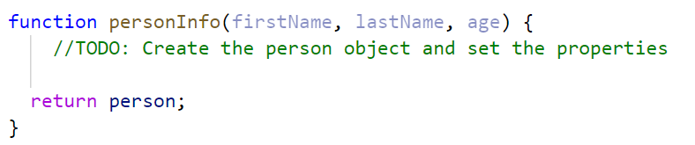

City
Write a function that receives a single parameter – an object, containing five properties:
{ name, area, population, country, postcode }
Loop through all the keys and print them with their values in format: "{key} -> {value}"
See the examples below.

Examples
Input | Output
{  name: "Sofia",  area: 492,  population: 1238438,  country: "Bulgaria",  postCode: "1000"  } | name -> Sofia  area -> 492  population -> 1238438  country -> Bulgaria  postCode -> 1000
{  name: "Plovdiv",  area: 389,  population: 1162358,  country: "Bulgaria",  postCode: "4000"  } | name -> Plovdiv  area -> 389  population -> 1162358  country -> Bulgaria  postCode -> 4000

Convert to Object
Write a function that receives a string in JSON format and converts it to an object.
Loop through all the keys and print them with their values in format: "{key}: {value}"

Examples
Input | Output
'{"name": "George", "age": 40, "town": "Sofia"}' | name: George  age: 40  town: Sofia
'{"name": "Peter", "age": 35, "town": "Plovdiv"}' | name: Peter  age: 35  town: Plovdiv

Hints
- Use JSON.parse() method to parse JSON string to an object
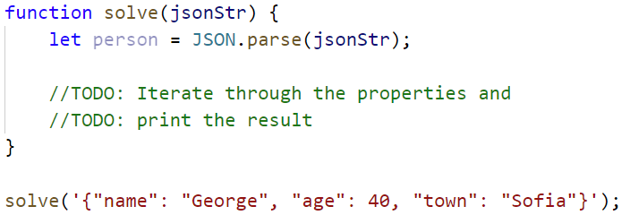

Convert to JSON
Write a function that receives a first name, last name, hair color and sets them to an object.
Convert the object to JSON string and print it.
Input is provided as 3 single strings in the order stated above.

Examples
Input | Output
'George', 'Jones', 'Brown' | {"name":"George","lastName":"Jones","hairColor":"Brown"}
'Peter', 'Smith', 'Blond' | {"name":"Peter","lastName":"Smith","hairColor":"Blond"}

Hints
- Use JSON.stringify() to parse the object to JSON string
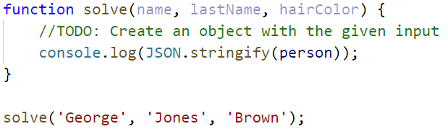

Cats
Write a function that receives array of strings in the following format '{cat name} {age}'.
Create a Cat class that receives in the constructor the name and the age parsed from the input.
It should also have a method named "meow" that will print "{cat name}, age {age} says Meow" on the console.
For each of the strings provided, you must create a cat object and invoke the .meow () method.

Examples
Input | Output
['Mellow 2', 'Tom 5'] | Mellow, age 2 says Meow  Tom, age 5 says Meow
['Candy 1', 'Poppy 3', 'Nyx 2'] | Candy, age 1 says Meow  Poppy, age 3 says Meow  Nyx, age 2 says Meow

Hints
- Create a Cat class with properties and methods described above
- Parse the input data
- Create all objects using the class constructor and the parsed input data, store them in an array
- Loop through the array using for…of a cycle and invoke .meow() method
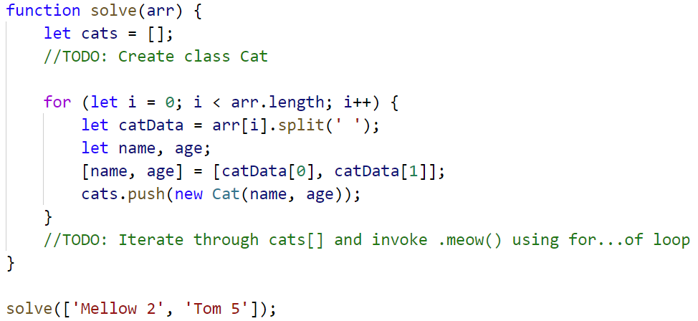

Songs
Define a class Song, which holds the following information about songs: typeList, name, and time.
You will receive the input as an array.
The first element n will be the number of songs. Next n elements will be the songs data in the following format: "{typeList}_{name}_{time}", and the last element will be typeList / "all".
Print only the names of the songs, which have the same typeList (obtained as the last parameter). If the value of the last element is "all", print the names of all the songs.

Examples
Input | Output
[3,  'favourite_DownTown_3:14',  'favourite_Kiss_4:16',  'favourite_Smooth Criminal_4:01',  'favourite'] | DownTown  Kiss  Smooth Criminal
[4,  'favourite_DownTown_3:14',  'listenLater_Andalouse_3:24',  'favourite_In To The Night_3:58',  'favourite_Live It Up_3:48',  'listenLater'] | Andalouse
[2,  'like_Replay_3:15',  'ban_Photoshop_3:48',  'all'] | Replay  Photoshop

Solution:
Create a Song class with properties described above
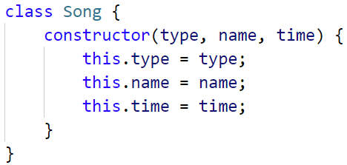
Create a new array, where you will store songs
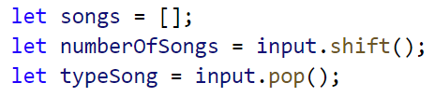
Iterate over the songs:
